# SAMPLE CODE OF A CSS BOX MODEL

<html>

<head>

<style>

div{

background-color: lightgrey;

width: 300px;

border: 15px solid green;

padding: 50px;

margin: 20px;

}

</style>

</head>

<body>

<h1>Demonstrating the Box Model</h1>

<p>The CSS box model is essentially a box that wraps around every HTML element. It consists of: borders, padding, margins, and the actual content.</p>

<div> this is how the content will be displayed in a sample css box model</div>

</body>

</html>

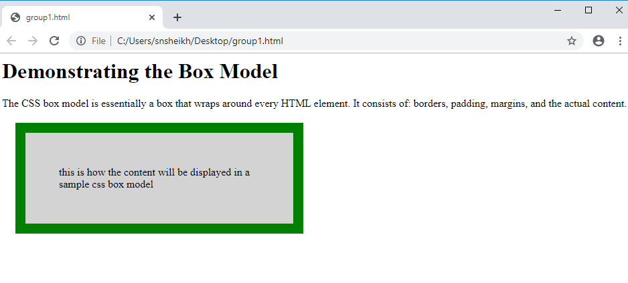

# GROUP MEMBERS

1. **Sheikh Salahudin noor 658085**
2. **Ochuodho Derrick Odhiambo 658377**
3. **Mkongwe Ian 659465**
4. **Ndiba John 659695**